SIMATS ENGINEERING (SAVEETHA SCHOOL OF ENGINEERING) Department of Computer Science and Engineering
ASSESSMENT TOOL 1 – EXPERIMENTS
Course Code: | CSA06 | Course Title: | Design and Analysis of Algorithms
CO Assessed: | CO3: Articulation  (BL4, BL5) | Assessment: | Assessment Tool 1 – Experiments
Weightage: | 40% of CIA | Total Marks: | 100
CO3 Statement: | Design Divide and Conquer algorithms for Merge Sort, Quick Sort, Binary Search and Matrix Multiplication
Student Name: | Ishwariya P | Reg. No.: | 192524445
Section / Batch: | 2025 | Date: | 10.8.26
Instructions to Students
• Answer the following question. Total Marks: 100.
• Write the algorithm and execute the code for the given experiment.
• Follow a well-structured, systematic approach to design and implement an optimal solution. • Provide insightful analysis with accurate validation, supported by clear documentation including diagrams, code, and results.

Question Type | Focus Area | Questions
Experiments | Design and Code for Divide and Conquer Algorithms: Merge Sort, Quick Sort, Binary Search, and Matrix Multiplication | Q1

SECTION A – Experiments
Code of Conduct
I __Ishwariya P(192524445)________________________ (Name / Reg No) certify that this submission is my original work and that I have adhered to the guidelines specified for this assessment. I understand that any violation of academic integrity rules will result in disciplinary action.
Signature of the Student: _________________________

RUBRICS FOR CALCULATION
Experiments
Criteria | Weightage | Level 4 –  Exemplary | Level 3 –  Proficient | Level 2 –  Developing | Level 1 –  Beginning
Understa  nding of  Concepts | 25% | Demonstrates thorough understanding and  effectively integrates  multiple  concepts/technologies | Good  understanding  with proper  integration of  most concepts | Basic  understanding;  limited or partial  integration | Poor  understanding  ; unable to  integrate  concepts
Experime  ntal  Design | 30% | Well-planned,  systematic  implementation with  optimal solution | Correct  implementatio  n with minor  issues | Basic  implementation  with errors or  inefficiencies | Incorrect or  incomplete  implementatio  n
Use of  Tools | 20% | Effective and advanced use of  tools/technologies with proper configuration | Appropriate  use of tools  with correct  execution | Limited or  inconsistent use  of tools | Incorrect or  minimal use  of tools
Analysis  of  Results | 15% | Insightful analysis with accurate interpretation and validation of results | Good analysis  with  reasonable  interpretation | Basic analysis  with limited  insights | Poor or incorrect analysis of results
Documen  tation | 10% | Clear, well-structured  documentation with  diagrams, code, and  results | Organized  documentation  with necessary  details | Basic  documentation  with missing  details | Poor or  incomplete  documentatio  n

Marks Evaluation:
Criteria | Wt. | Level 4 –  Exemplary | Level 3 –  Proficient | Level 2 –  Developing | Level 1 –  Beginning
Understanding of Concepts | 25%
Experimental Design | 30%
Use of Tools | 20%
Analysis of Results | 15%
Documentation | 10%
Total Marks (100):

Faculty In-charge | Course Coordinator | Head of Department
Name: | Name: | Name:
Signature: _______________ | Signature: _______________ | Signature: _______________
Date: ___________________ | Date: ___________________ | Date: ___________________

DAA LAB REPORT
Title: Performance Analysis of Recursive and Iterative Binary Search
1. AIM
To implement and analyze the performance of Recursive and Iterative Binary Search algorithms on datasets of varying sizes. The objective is to record the execution time and memory usage of both approaches, interpret the results, compare their efficiency in terms of time and space complexity, and determine which approach is more suitable for practical applications based on the impact of recursion on performance.
2. ALGORITHM
1. Start the program and take the input array of elements along with the target element to be searched.
2. Sort the input array in ascending order, since binary search requires a sorted dataset.
3. For the iterative method, initialize two pointers, low to 0 and high to the last index of the array.
4. Repeat the following steps while low is less than or equal to high: compute mid as (low + high) // 2.
5. If the element at mid equals the target, return mid as the result index.
6. If the element at mid is less than the target, update low to mid + 1 to search the right half.
7. If the element at mid is greater than the target, update high to mid - 1 to search the left half.
8. If low exceeds high, the element is not found; return -1.
9. For the recursive method, define a function that takes the array, low, high, and target as parameters.
10. If low is less than or equal to high, compute mid and compare arr[mid] with the target.
11. If equal, return mid; if arr[mid] is less than target, recursively call the function on the right half (mid+1 to high).
12. If arr[mid] is greater than target, recursively call the function on the left half (low to mid-1).
13. If low exceeds high, return -1 as the base case indicating the element is not present.
14. For both approaches, use the time module to record execution time before and after the search operation.
15. Use the tracemalloc module to record the current and peak memory usage during execution.
16. Print the dataset size, target element, result index, time taken, and memory used for both approaches.
17. Compare the recorded time and memory values of the recursive and iterative approaches.
18. Interpret the results: iterative approach generally uses constant O(1) auxiliary space, while recursive approach uses O(log n) space due to call stack overhead.
19. Conclude which approach is more efficient and suitable based on the observed time and space complexity.
20. Stop the program.
3. PROGRAM
import sys
import time
import tracemalloc

def binary_search(arr, target):
low = 0
high = len(arr) - 1
while low <= high:
mid = (low + high) // 2
if arr[mid] == target:
return mid
elif arr[mid] < target:
low = mid + 1
else:
high = mid - 1
return -1

def binary_recur(arr, low, high, target):
if low <= high:
mid = (low + high) // 2
if arr[mid] == target:
return mid
elif arr[mid] < target:
return binary_recur(arr, mid + 1, high, target)
else:
return binary_recur(arr, low, mid - 1, target)
return -1

def measure(func, *args):
tracemalloc.start()
start = time.time()
result = func(*args)
end = time.time()
current, peak = tracemalloc.get_traced_memory()
tracemalloc.stop()
return result, end - start, peak

if __name__ == "__main__":
data = input().split()
arr = sorted(int(x) for x in data[:-1])
target = int(data[-1])

print(f"dataset size:{len(arr)}")
print(f"target element:{target}")

print("\n__iterative binary search__")
idx, t, mem = measure(binary_search, arr, target)
print(f"result index :{idx}")
print(f"time taken: {t:.8f} seconds")
print(f"memory used: {mem} bytes")

print("\n__recursive binary search__")
idx, t, mem = measure(binary_recur, arr, 0, len(arr) - 1, target)
print(f"result index :{idx}")
print(f"time taken: {t:.8f} seconds")
print(f"memory used: {mem} bytes")

4. SCREENSHOTS
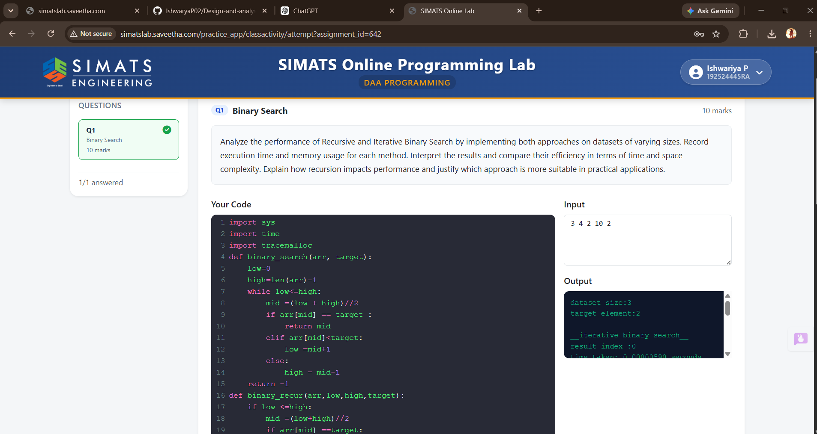

5. RESULT
The Recursive and Iterative Binary Search algorithms were successfully implemented and executed on the given dataset, and the objective of the experiment was achieved. The execution time for both approaches was found to be very small and comparable for the tested dataset size, while the memory usage of the recursive approach was observed to be higher due to the additional overhead of function call stacks. The iterative approach demonstrated better space efficiency with O(1) auxiliary space compared to the O(log n) space required by the recursive approach. Overall, the iterative method proved to be more suitable for practical applications involving large datasets and memory-constrained environments.

